
Monograph APA 7th ed.
Presented by Mrs. Carmen Amelia Acevedo, EAVIA Librarian

Choose your theme (define your task) - Choose a topic that motivates you. You must know something about the subject. Define the issue and think about the purpose of this writing and how you can help. Show your theme to your teacher by ________

- Find information about the topic (localize information) – now that you have your theme, search for information. Select from: books, encyclopedias, magazines, newspapers, posters, web pages (.edu, .org, .net) and databases (evaluate the information). Summarize and paraphrase it to avoid plagiarism.

A. Take notes: Avoid plagiarism and write quotes, citations, and References.

- Create a draft– to help you seek the “input” of others (suggestions from others):
teachers, peer, tutor or librarian.

- Consult the Publication Manual of the American Psychological Association (7th ed_{.),}
follow your teacher’s requirements (RUBRIC) to start your project. (use the
information).

Write your monograph! A. A nice and organized monograph most contain:
8.5 X 11 white paper (both side if your professor authorized)
Times New Roman font | size 12 (Calibri 11, Arial 11, Lucida Sams Unicode 10, Georgia 11)
All text double-spaced (not 4 between paragraph).
Left alignment.
1” margins.
Bold headings in the text.
Just one space between words and after punctuation.
B. Prepare References: minimum.

Monograph APA 7th edition

OBESITY IN CHILDREN 1

Can Medication Cure Obesity in Children?

Carmiña Avilés Pérez

Prof. E. Rodríguez

Escuela Elemental y Superior Antolina Vélez

English 11th

April 13, 2023

Title page- It is better to select the title when you finish the monograph. Prepare between two or three then choose one. The title should summarize the main idea. Write a title that will attract, convince, and encourage the reader. The title should be centered on the page, double-spaced, not bolded, underlined, or italicize.
The Running head: cannot exceed 50 characters, including spaces and punctuation, it is a shortened version of the title. Write in capital letters.
Repeat on each page.

Appreciation - your collaborators, tutors or guides. When you write it, you put it in the right margin "right align" in a block with single space.

Dedicatory -dedicated to important people or your inspiration. When you write it, you place it in the
right margin "right align" in a block with single
(Both Appreciation and Dedicatory our assignment indicates it as a requirement.)
OBESITY IN CHILDREN 3

Dedicatory

To all the boys and girls that fight
with their self-esteem and all
their emotional helpers.

Abstract:  Table of Contents | a brief summary of the paper, quickly review the main points and purpose of the monograph. It should be 150-250 words. Centered the word “Abstract”. Do not indent. Our assignment instructions indicate it as a requirement.  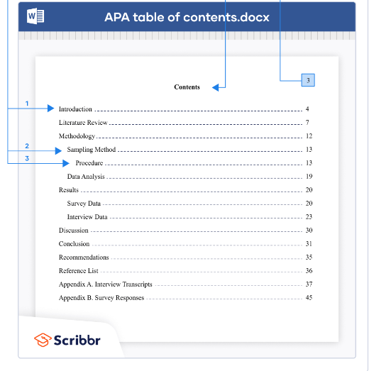  The table of contents comes between your abstract and your introduction. It should be written in the same font and size as the rest of your text (usually 12 pt Times New Roman). At the top of the page, write Contents or Table of Contents, centered and in bold.
Text or body: | -start with an Introduction. It should provide background information and support, an anecdote, a historic detail, or an era and place location. The introduction presents the problem that the paper addresses.  Rewrite the Title of your Monograph to start the body.  Write an argument statement. Here you present a properly organized analysis about your theme. Avoid insignificants details. Focus on the updated information and the most important conclusions. Your presentation must be justified and supported by previous investigations. Cite and follow the instructions to do it properly (Cummings, 2012). Include an Appendix, refer to it in the body of your paper and create a bibliography too (see Appendix A).
Conclusion | -restates the problem the monograph presented and can offer ideas for further research. Start with a sentence that supports or refuses the problem. Highlight the consequences and the conclusions of your project. Guides questions: How is my monograph a contribution? How does it resolve the problem?

References: Basic Rules (https://owl.english.purdue.edu/owl/resource/560/05/)
- At the end of your paper on a new page separate. Label this page "References" centered
at the top of the page. All text should be double-spaced.
- All lines after the first line of each entry in your reference list should be indented one-half inch from the left margin. This is called hanging indentation or French indent.
- Authors' names (last name first); give the last name and initials for up 20 authors.
- Alphabetized by the last name of the first author of each work. Numbers located before letters in the correct order. (Omitted the articles (but write them): A, An, The). NO bullets, not numbered.
- Capitalize all major words in titles.
- Italicize titles.
- More information:
+use the Publication Manual of the American Psychological Association 7th ed. Ask your librarian (caracevedo@aguadilla.inter.edu), visit the APA official webpage http://www.apa.org/
+ https://owl.english.purdue.edu
+ visit the blog Manejo de Información https://carmenamelia4.blog

OBESITY IN CHILDREN
References
Air Pollution and Your Lungs. (2023). Asthma + Lung UK. https://www.asthmaandlung.org.uk/living-with/air-pollution/your-lungs
Air Pollution at Home. (2023). Asthma + Lung UK. https://www.asthmaandlung.org.uk/living-with/indoor-air-pollution/home
Air Pollution: Effects on Wild Animals. (2012). Canada.ca. https://www.canada.ca/en/environment-climate-change/services/air-pollution/quality-environment-economy/ecosystem/wild-animals.html
Bhopal Gas Tragedy- [December 2, 1984] This Day in History. (2017). BYJU’S. https://byjus.com/free-ias-prep/this-day-in-history-dec02/#:~:text=On%20the%20night%20of%202,effects%20
continue%20to%20this%20day
Obesity. (2019). World Health Organization. https://www.who.int/health-
topics/obesity#tab=tab_3

13

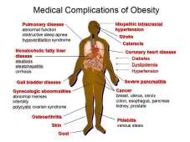
Appendices: The Appendix is presented at the end of your monograph. It provides brief content that supplements your paper: tables, graphics, illustrations, interviews, photos, etc. If you are including an appendix, refer to it in the body (see Appendix A). It should be organized in alphabetical order in your text. Each entry in the Appendix should be in a separate paper each one. Center the title “Appendix A”, include a title that explains the content. Remember to avoid plagiarism:

OBESITY IN CHILDREN

14

Ap
pe
ndi
x A

Obesity affects the body

create the reference.

Reflection: about the process from the beginning to the end.

-------------------------------------------------------------------
Review, check the orthography, grammar, and APA style formatting. Some teachers, the librarian, peers, or tutors can help. Ask yourself: What have I learned?

Updated Dec. 2023

