
Escuela Elemental y Superior Antolina Vélez
Universidad Interamericana de Puerto Rico
Recinto de Aguadilla
Library Media Center/Biblioteca

BASICS REQUIEREMENTS to MLA 9th ed. and APA 7th ed. Format
Presentation by Mrs. Amelia Acevedo (February 2026)
Modern Language Association- MLA | American Psychology Association- APA
General requirements:  Paper 8.5 x 11  Write on one side of the paper  Font Times New Roman 12 or Arial 12  Double space  Margins 2,54 or 1”  Left align  One space after punctuation  Not bold, neither underline  Include figures (visual or tables)  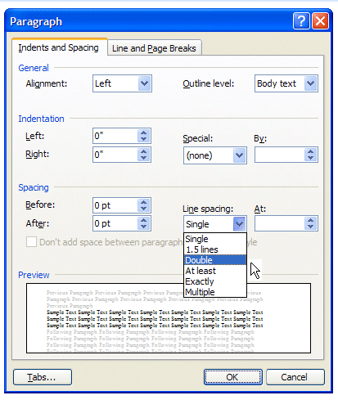 | General requirements:  Paper 8.5 x 11  New! Write on one side of the paper (Optional both side)  New! Font: Times New Roman 12, Calibri 11, Arial 11, Lucida Sans Unicode 10, and Georgia 11.  Double space  Margins 2,54 or 1”  Left align  One space after punctuation  Not underline, bold only the subtitles  Visual or tables most been in the Appendices
Pages: Last Name and page # | Page numbers and running head: in the upper right-hand corner of each page, include a 1-2 words version of your title, no more than 50 characters (IN ALL CAPS). Follow with five spaces and then the page number or write the running head in the upper left-hand corner and the page number at the right-hand.
Id block: upper left-hand corner  Student Name  Professor Name  Course title and group  Date: Universal= Date Month Year  English= Month Day, Year  Español= día mes año  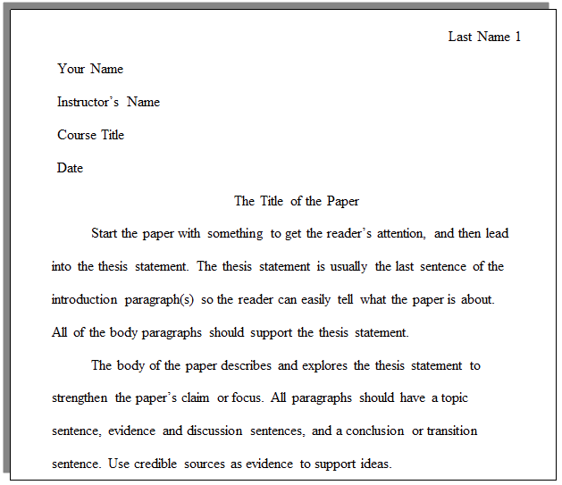  Title: center (no bold, neither underline) If the title includes title book or a document title, write in Italic. | Title Page:  Center  No underlined, no italic, no bold  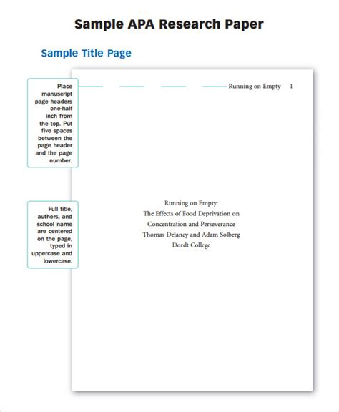or 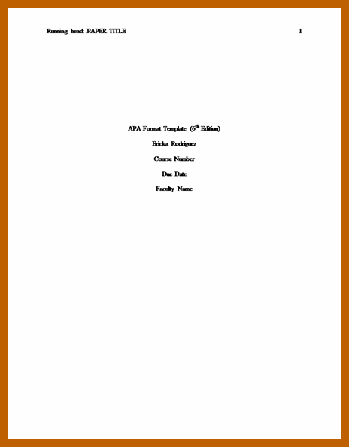  Full title of the paper  Your Name  The Name of the Institution  or  Full title of the paper  Your name  Professor Name  The Name of the Institution  Date
Dedicatory or Appreciation- are optional
Table of Contents- is optional
Abstract:150-250 words, no indent.
Text body: Use indent. Write in paragraphs. Write the introduction, the contents, and the conclusion in a big essay format. | Text body: start with the title of the project, write the introduction, the body, and the Conclusion can be in bold. “Less is more”. Suggestion- eight sentences paragraph.
Images or tables are included in the text body write (see figure 1)- number order (véase figura 1). Include the image and behind it writes: Figure 1- title or description / Figura 1- título o descripción  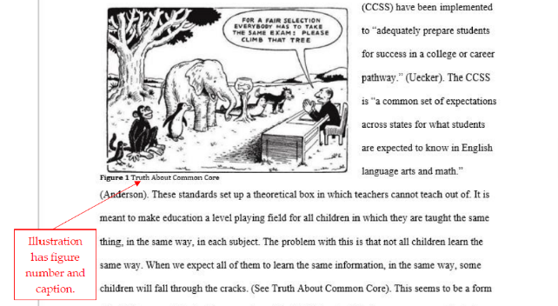 | Images or tables = Appendices: on a separate page, at the end.  In the text body write (Appendix A)- (Apéndice A). alphabetical order  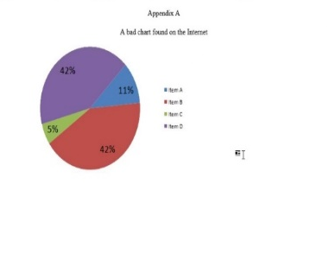  In Appendices page- include the image and a title or description.
In-text citations: basics rule  author’s last name and the page number  (Ruiz 56) (Title page) | In-text citations: basics rule  author’s last name and the year of publication  (Ruiz, 2011) (Title, year)
Works Cited- list of sources of information  Page apart at the end of the essay  Alphabetical order  French indent (hanging indent)  “Titles.” in “quotation marks”  Publisher in Italic  No author- use the “title.”  No date- (n.d.) Sin fecha (s.f.)  Punctuation is so important.  Remove hyperlink  Book example:  DiSpezio, Martin. “Science Fusion.”  McHaughton, 2017.  Webpage example:  “Water pollution.” Environmental Center,  2019,  https://www.environmentalcenters.org  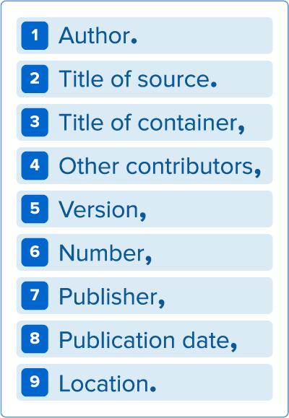 | References- list of sources of information.  Page apart at the end of the essay in alphabetical order.  New! Authors up to 20. Surname, Initial.  French indent (hanging indent= tab)  Italicize the titles  Punctuation is so important.  No author- use the title in italic  No date- (n.d.) Sin fecha (s.f.)  New! Do not write the publication city.  New! URL address only www  New! Remove Hyperlink optional  Book example:  DiSpezio, M.A. (2017). Science Fusion. McHaughton.  Webpage example:  Water Pollution. (2019). https://www.environmentalcenters.org  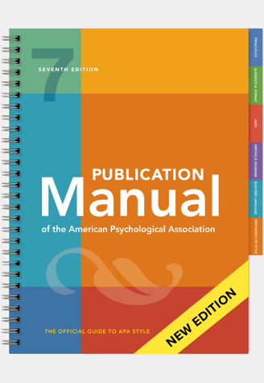
- MLA typical use in Humanities (Languages, Art). APA typical use in Social Sciences (Psychology, Sociology).
- Any information that is not your own, most be cited, avoid plagiarism (Reglameto de EAVIA en Capítulo VI Actos Sancionables y Procedimientos Disciplinarios. Artículo 1= Sujetos a Sanciones Académicas: Plagio en cualquiera de sus modalidades incluyendo copiarse en los exámenes y otros trabajos académicos.)
- The librarian offers the APA and MLA workshops, and she is available to corroborate the bibliographies by email or in the library. Refer to Manejo de Información blog https://carmenamelia4.wordpress.com/ to found more details.
- Formato APA con el Generador APA/MLA de Scribbr https://www.scribbr.es/citar/generador/apa/
___________________________________________________________________________________________
References

APA vs MLA. (2018). https://libguides.enc.edu/criticalwriting

Manejo de información. (2026). https://carmenamelia4.wordpress.com
Streefkerk, R. & Streefkerk, R. (2019, November 5). APA Manual 7th Edition: The 17 Most Notable Changes.
https://www.scribbr.com/apa-style/apa-seventh-edition-changes/.
Universidad Interamericana de Puerto Rico Recinto de Aguadilla. (n.d.) Aspectos básicos del Manual APA. Adaptado por Lizzie Colón. [Manual].
Aguadilla, PR: UIPR Aguadilla.

