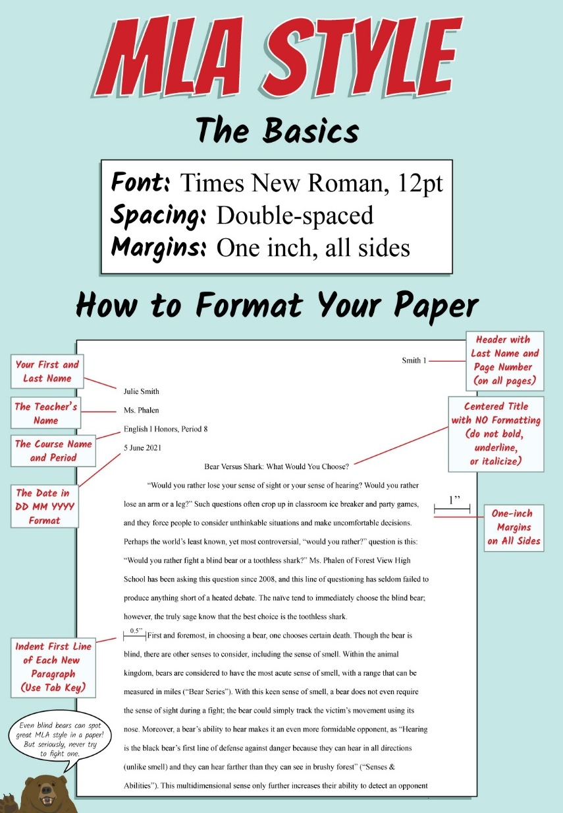

*Works Cited- Page apart, alphabetical order and hanging indent = French indent. Double space.
Book:
Last Name, First Name. Title. Publisher, Date.

Book with no Author: Title. Publisher, Date.

Website:
Last Name, Name. "Title of Webpage.” Title of Website, Publisher, date published in day month year

format, URL.

Website with No Author:
“Title of Webpage.” Title of Website, Publisher, date published in day month year format, URL.

Acevedo 2
Works Cited
Blanco, Laura. Found the real happiness. Norma, 2024.
“MLA Works Cited Page: Books.” Purdue University, 2 June 2025,
https://owl.purdue.edu/owl/research_and_citation/mla_style/mla_formatting_and_style_guide/
mla_works_cited_page_books.html.
Smith, Maureen. "The right way to enjoy the life.” Urban People.org, 17 November 2026,
www.urbanpeople.org/life.
Who win lion vs. tiger? Scholastic. 2022.

